**SSH Lab:**

In the CCNA curriculum, understanding and configuring SSH is an important topic, as it is a widely-used secure protocol for remote access and administration of Cisco network devices.

Here are the key things you need to know about using SSH in a CCNA context:

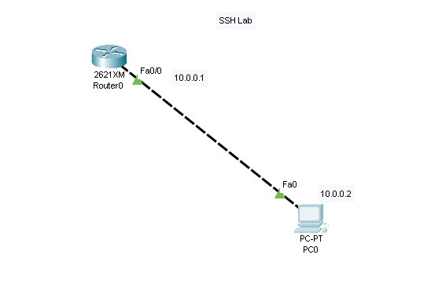

Importance of SSH in CCNA: SSH is a critical protocol for secure remote access to Cisco routers, switches, and other network devices. It replaces the older, less secure Telnet protocol. Mastering SSH configuration and usage is essential for CCNA certification.

SSH Configuration on Cisco Devices: To enable SSH on a Cisco device, you need to configure the following:

Generate a crypto key pair (RSA or DSA) for the device.

Configure a domain name for the device.

Enable the VTY lines (virtual terminal lines) for SSH access.

Configure a username and password for SSH access.

Here's an example configuration:

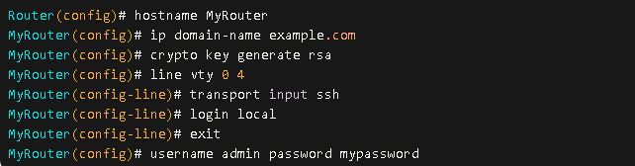

Connecting to Cisco Devices using SSH: To connect to a Cisco device using SSH, you can use the following command:



Replace username with the configured username, and device_ip_address with the IP address or hostname of the Cisco device.

SSH Security Considerations: SSH provides a secure method of remote access by encrypting the communication between the client and the Cisco device. This helps prevent eavesdropping and man-in-the-middle attacks. CCNA candidates should understand the importance of SSH for secure network administration.

SSH Troubleshooting: If you encounter issues with SSH connectivity, you might need to troubleshoot factors like:

Correct username and password

Proper configuration of the crypto keys, domain name, and VTY lines

Firewall or access control list (ACL) rules that might be blocking SSH traffic